**First Presbyterian Session Members**

Barb Dewey – Clerk of Session

Troy Johnson – Elder (2)

Dave Williams – Elder (1)

Betty Lou Cravens- Elder (2)

Heidi Hoff – Elder (1)

Judy Helle – Elder (3)

Jim Rylander – Elder (3)

Jim Risbrudt – Treasurer

**Shared Ministry Council**

Jim Borgrud – Chm. (3)

Val Martin- Vice Chm. (3)

Barb Dewey – Secretary (2)

Jim Risbrudt – Financial Secretary (1)

Dave Olson (1)

Pat Welch (2)

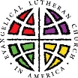

**OS-TML Church Council**

President – Pat Welch (1)

Vice Pres. – Joyce Samuelson (1)

Secretary – Christina Saurer (1)

Treasurer – Debbie Wilke (1)

Deacons – Teresa Akerman (2)

Mitchell Sterns (3)

Jerry Thormodson (3)

Trustees - Jim Borgrud (2)

Kelly Walvatne (2)

Brian Hansel (3)

**Women of the ELCA Co-Presidents**

Karen Nelson

Shirley A. Frigaard

**Board of Education**

Christina Saurer (2)

Sara Hage (1)

Ashley Lee (1)

**Endowment Fund Board**

Julie Olson (1)

Karen Nelson (1)

Lyle Skinnemoen (2)

Deb Thormodson (3)

**Our Savior’s Cemetery Board**

David Schroeder, Sexton (1)

Kyle Frigaard

Dean Thorsen

Gaylan Thormodson

Larry Sonmor

**INDEX**

Page 1 Minister’s Musings

Pages 2-3 First Presb. News

Pages 3-4 Shared Ministry News

Pages 4-7 OS-TML News

Calendars

**The Minister’s Monthly Musings –December, 2016**

**Advent Edition**

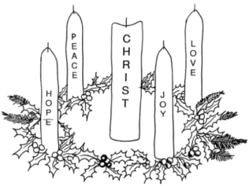

**Running Red Lights**

I have a confession to make. When Lance waved me down in my car on Lincoln Ave. I initially thought it was to scold me. See, I was still mulling over the pastoral visit I had come from when I pulled through a red light. And suddenly there was Lance, standing in the median with a box. Probably just trying to cross the street to make a donut delivery and understandably fed up with all the discourteous drivers. I was acutely aware of my white clerical collar as I rolled down my window and prepared to take my deserved lecture on distracted driving. I figured I would probably see myself in a Fergus Journal headline before long: “Pastor Pesters Pedestrians with Perilous Driving.” So imagine my surprise when Lance told me, “It looks like you could use a box of donuts today.” Instead of getting what I deserved (an earful), I was the recipient of the Falls Bakery curbside donut delivery surprise (a mouthful). In my business we call this deserving judgment but receiving grace. The truth is, we “run red lights” every day. And turning to God in repentance, we receive His mercy again and again. This is God’s unmerited favor. And because of Christ, we are highly favored. Which is why in Advent it is especially fitting that we meditate “on the glory of the one and only, full of grace and truth” (John 1:14). Advent is about the surprising gift of God’s Son, our Lord, who comes not to be served, but to serve!

**Signs of the Season**

Advent marks a time of preparation as we anticipate again the celebration of the Nativity of Jesus Christ—and even more importantly, prepare for his Second Coming! We mark this march toward the advent and Parousia of our Lord with an Advent Wreath: four candles (three blue or violet candles and one rose- or pink-colored ones) surrounding a white one. The ring of four candles marks Advent as a penitential season—a time for self-examination and repentance as we confess our need for a savior. All four candles are lit to symbolize Christ’s coming into the world, each representing virtues that Christ embodied: Hope, Love, Joy and Peace. Joy corresponds with the rose/pink candle which is traditionally lit on the third Sunday in Advent, called Gaudete Sunday (from the Latin “to rejoice”). At the center of the wreath—the “reason for the season”—is the Christ Candle. This candle is traditionally lit on Christmas Eve or Christmas day to remind us that Jesus is the light of the world (John 8:12). These five candles are embedded in a wreath whose evergreen circle symbolizes God’s eternal reign. Each part of this wreath points beyond itself to something sacred—signs of this season reminding us that God has drawn near to us.

**Gift-wrapped in Human Skin**

At the heart of our seasonal celebration is recognition that we’ve been given a gift whose worth we cannot fathom—like a present we treasure even though we can’t fully unwrap it. That the Son of God should drape himself in our flesh, taking on our limitations and suffering, all out of deep love for us—this should fill us with such awe! And add to this mystery the miracle of his conception and birth: that the eternal God who gives life to every created thing should now fashion for himself a life in Mary’s womb! How is it that the very Word that spoke the cosmos into being is now subject to an infant’s inarticulate lips and hands? The very God we worship, unable to raise his head or focus his eyes? Yet as Saint Athanasius liked to say, the universe was not left void of his activity and providence even for one instant! Beyond the joy of gathering with friends and family, this liturgical season is about contemplating anew the miracle of Advent and the mystery of the Incarnation. So keep awake! Be ready! And ask God to cultivate in you a childlike wonder that holds fast to the promises that for your sake God has taken on human form—mind, body, and spirit—to redeem them and all of creation! This is beyond anything for which we could ask or imagine. And so much more than we deserve.

In the name of the Father, and of the ☩ Son, and of the Holy Spirit. Amen.

Rev. Matthew Zelie †

First Presbyterian News

**Regular Session Meeting**

**November 8, 2016**

The regular Session meeting of the 1st Presbyterian Church of Ashby was held at 6 PM , November 8, 2016 at the church. Those present were Moderator Reverend Matthew Zelie, Ruling Elders: Heidi Hoff, Dave Williams, Betty Lou Cravens, Troy Johnson, Judy Helle and Jim Rylander, treasurer Jim Risbrudt and Clerk Barb Dewey, guests: Troy and Emily Mickelson and daughters Ella and Andie. The meeting was opened in prayer by Rev. Zelie and together we read the Shared Ministry Mission Statement. A quorum was present and docket approved.

After examination by the Session, Troy and Emily Mickelson were accepted as members by Confession of Faith.

The minutes were read and approved after correction. The Treasurer’s report showed $8552.82 in checking with the insurance bill of $3140.00 to be paid. The PW donated $2000 from the fall supper. In Savings: Building Maintenance: $8.53, Dishwasher Fund: $2391.90, Grover Bible Trust: $224.30, Larson/LaValleur Camp: $987.37, Memorial (undesignated) $4590.64, Music: $3578.88, General Fund Savings: $4300.79, Starner Memorial Fund: $2975.85. The report was voted approved.

**Pastor’s Report:** communion was celebrated Sunday, November 6, 2016 with Rev. Matthew Zelie and 40 communicants. October he has been working on the Shared MInistry budget , planning for Advent, Confirmation prep and taught Classes, Youth Group Bible Study and hike night, 3 Brown Bag lunches, Broen Home communion and the “Being Mortal” film presentation at Broen. 2 home visits. 2 counseling sessions. Attended fall supper. 6 days of vacation were spent out East with family.

**Communications:** a memorial gift from Wally Bullis family was gratefully received.

**Committee Reports:** Shared Ministry 2017 Budget for $111,840.08 was presented. Our Saviors Ten Mile Lake will be responsible for 62% and our 100 members on October 31st will pay 38%. The Shared Ministry account will be reduced to $25,000 on hand by each church paying less into the account over the next year.

**Buildings and Grounds-**Jim Rylander will work on hymn book holders for back pews.

**Christian Education-** The Session agreed to change in worship hour on December 11 to 9 AM to accommodate Our Savior Ten Mile Lake Sunday School Christmas Program and potluck.

**Worship:** Pastor Matt will contact Yvonne Breuer about the Hanging of the Greens service for the first Sunday in Advent. Sunday School Christmas Program is December 18. Christmas Day will be at church. Baptisms for Hadley, Tripp & Ty Hoakanson will be December 4, 2016, Heidi will assit.

**Stewardship-**Jim Risbrudt, Heidi and Judy will work on budget. Dave and Heidi with Nominating Committee working on Elder candidates. The Session voted to accept committee reports.

**Old Business-** Community Thanksgiving Service with Peace/Grue, OSTML and 1st Presbyterian will be Tuesday, November 22nd at Peace Church. New member recognition Sunday, November 20. There was discussion about homebound communions -with goal of quarterly visits.

**New Business:** Starner Fund distribution was discussed to be decided at next meeting. The Session voted to contribute $150 to Peace/Grue Lutheran for the Community Harvest Meal. Old books from the 1800’s were discovered during cleaning-these will be preserved as they were sent to our beginning church as “missionary work”. The Session granted Kris Williams permission for use of facilities for piano recital on December 19. The Session voted to purchase a new vacuum cleaner from Dan’s Vacuum for $599.

Elder Training was done on what Presbyterians believe. Presbyterians believe in predestination-that God has determined who will follow Him.

The meeting was adjourned and closed with prayer. The next meeting will be December 1 at 6 PM.

Rev. Matthew Zelie, Moderator Barbara Dewey, Clerk of Session

****

**December**

2nd Vonnie Breuer

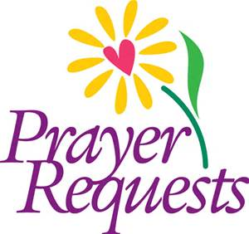

Ian Bertram, J.R. Caraway, Jon Heinrich, Brady Kruize, Jarod Johansen and All military personnel; Members and Friends: Delores Bullis, Marge Boren, Whitney Gramm, and Jim Karl.

First Presbyterian News

**Disciples for December:**

Al & Janet Larson

Judy Grecco

Mike Boren

Tom & Cindy Welch

Dave & Kris Williams

Don & Cookie Williams

Cliff & Val Martin

Harvey & Diane Erickson

John Clark

****

**Mark your calendars!!**

On December 11th, First Presbyterian will hold worship at 9:00am, instead of the usual 10:30am, for that Sunday only!

The Christmas program will be December 18th at 10:30 am.

**Per Capita**

Our Westminster Confession of Faith says, “all believers are, therefore, under obligation to sustain the ordinances of the Christian religion where they are already established, and to contribute by their prayers, gifts, and personal efforts to the extension of the Kingdom of Christ throughout the whole earth” (The Book of Confessions, 6.058).

Per capita for 2017 is $39.80. Members are encouraged to give before the January 31st deadline. This is a fundamental way in which all of the nearly 11,000 of the Presbyterian Church (U.S.A.) are connected and participate in the work of the wider church.

****Rooted in the covenantal nature of the Presbyterian church, per capita is the church's "community fund" whereby Presbyterians mutually share the costs of supporting the work of churches, commissions, general assembly, and elder training, Please consider paying your per capita share to support the work of Christ's Body at the global, regional and local levels. To God be the glory--great things He hath done AND is doing!

Shared Ministry News

**CONFIRMATION HAS BEGUN!**

Confirmation is a two-year program that serves 7-9th graders in our Shared Ministry and focuses on learning about Christ, his Church, and the apostolic faith. Last year we studied the distinctive practices of Lutherans and Presbyterians but also the creeds and theology they share. This year we study the Reformation and Holy Scripture. Classes are held Wednesdays, 7-8 pm, at First Presbyterian or Our Savior’s-Ten Mile Lake. During the seasons of Advent and Lent, students are required to participate in the Wednesday night services in lieu of regular class time. If you have students interested in participating, please email me so that I can send along the sign-up/contact sheet and schedule.

Nov. 30 7pm Advent Service Ashby

Dec. 7 7pm Advent Service Dalton

Dec. 14 7pm Advent Service Ashby

Dec. 21 7pm Advent Service Dalton

Dec. 28 NO CONFIRMATION

**Service of Remembrance**

Glende-Nilson Funeral Home invites you and your family to a Holiday Service of Remembrance, Thursday, Dec. 1st at 6:30pm at their chapel in Fergus Falls. This candlelight service will blend scripture, music, and a message of hope, centered on remembering those who have gone before us. Refreshments and a time of fellowship will follow the service.

**Parsonage Open House**

Join Matt and Jess and Luke on December 3rd for an open house at the parsonage (108 N Central Ave, Dalton) from 11am-4pm! We’d love to see you there!

**Christmas Cantata**

The Christmas Cantata ‘Joy’ by Joel Raney will be presented at Eagle Lake Lutheran Church Saturday, December 3 at 7pm and Sunday, December 4 at 10:15am.

****

**Service Time Change**

Please note that our services will switch times for ONE DAY ONLY on Dec. 11th. First Presbyterian will hold worship at 9am, and OSTML will hold worship and a Sunday School Christmas Program at 10:30am, with a lunch following the service.

****

**To Our Snowbirds**

Before you take wing for lower latitudes and warmer climes, please update the office with your address and schedule so you can continue to receive the monthly newsletter. Thanks!

****

**Thank You**

A huge ‘thank you’ to Jim Borgurd and Darrell Kilker for working on the parsonage stairs this month!!!

**Wedding Shower**

An open house wedding shower in honor of Kelli Meehl, bride-to-be of Lucas Heeter will be held at OSTML on Saturday, Dec. 10th at 10am. All are welcome to celebrate with us!

**Fergus Falls Community Food Shelf**

Dear Congregation;

Recently I have received questions regarding a mailing sent by North Country Food Bank, located in Crookston Minnesota. Many of you may recall receiving it in your own mail boxes over the years. It is not a mailing from your local Fergus Falls Community Food Shelf. To be clear, we are two separate entities.

While both organizations are worthy of your donations, the Fergus Falls Community Food Shelf operates solely on the generosity of the good people, businesses, organizations and churches in our area. Each year, our major fund raising drive is in March. At that time, you will receive a donation request from us.

North Country Food Bank's area of focus is Northwestern Minnesota.

The focal area of the Fergus Falls Community Food Shelf is right here in your community and within approximately a ten-mile radius of Fergus Falls. We reach out to help your neighbors, friends and family members. In fact, we serve about 1,000 people each month, 400 of those are children under the age of 18.

I encourage you to continue to give generously to your local food shelf.

Sincerely,

Jerry Fletcher

President

Fergus Falls Community Food Shelf

PO Box 136

Fergus Falls MN 56537

OS-TML News

**OSTML CHURCH COUNCIL MINUTES**

Our Savior’s-Ten Mile Lake Church Council met Nov 15th, 2016 at 7:00 pm

Members present: Pastor Matt, Joyce Samuelson, Christina Saurer, Pat Welch, Teresa Akerman, Debbie Wilke, Jim Borgrud, Jerry Thormodson, Kelly Walvatne, Brian Hansel and Mitchell Sterns

**Devotions:** Christina

The Mission Statement was read in unison.

**Secretary’s Report:** The report was reviewed. A motion was made by Kelly to accept the Secretary report and seconded by Jerry. Motion carried.

**Treasurer’s Report:** Presented by Debbie with a balance of $10,015.37.

**President’s Report:** Nothing to report.

**Pastor’s Report:** October was a month of preparation for Advent and Christmas and continued prep for Confirmation classes. I led my second premarital session with Megan and Zach (10/2). There were 12 meetings in the church office with OSTML members; 6 hospital or health care visits; one Holy Communion service on a home visit; and 2 pastoral care home visits; 2 Confirmation classes (10/5, 10/12); a 6 day trip to PA and NH to see family (11/20-11/25); 2 Youth Group gatherings with between 15-20 kids with Bible study on (10/10) and an Inspiration Peak Night Hike/Prayer gathering/cookout; Jess and I accompanied Peggy and some Presbyterians to the Broen Home showing of the film “Being Mortal” about end-of-life decision-making and care-giving; on Pat Welch’s invitation I helped out some church members at the Fergus Falls food pantry (10/14); a Shared Ministry meeting on (10/17); a Broen Home Communion service (attended by only Peggy Lien and me) (10/19); a couple meetings this month to organized the Cemetery Board and sign-project with an official board meeting (10/27); and a Trunk-or-Treat event with Pat Welch, Lori & Dean Thorsen; Kadie and Ashley Schroeder, and Pastor Matt and baby Luke (and Sunday School goodies bags/invites from Christina Saurer)—we had a lot of fun and saw around 50 kids. We will discuss adjusting time and Sunday School role next year. This month Jess and I spent a lot of time updating the Shared Ministry budget for approval by SM council and then both our special meetings in January. Special thanks to Jerry and Bob Thormondson and for leaf removal and gutter cleaning this week!

**Trustee’s Report:** New carpet was installed in the parsonage on the steps.

**Deacon’s Report:** Mitchell will assist with communion on 12/4 and Jerry will assist on 12/25.

Joyce made a motion to accept all reports as presented and Mitchell seconded. Motion carried.

**Old Business:** With the Annual Meeting coming soon, we need to think about new council members as Pat, Joyce and Christina have terms that are coming up. The altar guild is looking at purchasing a few new banners, A motion was made by Jim for $477 from the memorial savings account to be used on this purchase. It was seconded by Jerry. Motion carried.

**Calendar Items:** The Sunday School Christmas program will be December 11th at 10:30 am followed with a potluck provided by the youth. The free will offering will go to them. Christmas Eve service is Saturday 12/24 and Christmas Day at 9am.

Advent schedule:

11/30 Advent 1 @ 7pm – Ashby

12/7 Advent 2 @ 7pm - Dalton

12/14 Advent 3 @ 7pm – Ashby

12/21 Advent 4 @ 7pm - Dalton

**New Business:** Shared Ministry and Pastor’s salary - draft reviewed. The executive committee will meet 12/7 after the Advent service to go over the OSTML budget, We will decorate the church on Saturday 11/26 at 1000am. Joan Swendsrud and family will be using the church for a shower on Dec. 10th at 1000am. A motion was made by Kelly to remove Marcy’s name from the safety deposit box, Cemetery Fund Checking Account and the General Fund Checking Account. Jessica Zelie needs to be added to the safety deposit box, Cemetery Fund and General Fund checking accounts. Debbie Wilke needs to be added to the Cemetery fund checking account. Seconded my Mitchell. Motion carried. The youth will be having a bake sale at the Community Center on Dec 10th during Santa Days.

A motion was made to accept old and new business by Teresa and seconded by Joyce. Motion carried.

Next meeting: 12/15/16 at 7pm.

Devotions by Mitchell.

The meeting closed with prayer by Pastor Matt and the Lord’s

Prayer was recited in unison.

Meeting adjourned.

Secretary, Christina Saurer

**Prayer Requests:** Trevor Boe and Dale Helgeson.

**MINNEAPOLIS INSTITUTE OF ART EXHIBITION**

Mia would like to invite you to a special exhibition, ***Martin Luther: Art and the Reformation***. The exhibition runs from October 30-January 15. To reserve tickets, call 612-871-3000 or go online to [www.artsmia.org/luther](http://www.artsmia.org/luther).

**Our Savior’s-Ten Mile Lake Building Use Reminders**

**Ushers:** Please remember to review the table of duties posted by the entrance to the steeple bell tower. These include: turning in a Sunday morning head count to the office, lighting candles and notifying the altar guild if taper wicks are low, turning on the PA system and altar lights. But even more importantly: Thank you for serving us by ushering, greeting, and assisting in worship. We are so very grateful for you!

**Everybody else:** As we lean into the winter months, please remember to turn down the basement thermostat (if meeting downstairs, instructions posted on wall), and also to lock doors and turn out lights if you are the last one in the building. We are blessed with a wonderful building and want to be a good stewards of our resources. Thank you!

**Christmas Poinettias**

If you would like to donate a flower in memory of loved ones, you can order them from Mary Jo or Bonnie either on Sunday mornings or by calling Mary Jo at 747-2606 or Bonnie at 747-2865. The cost is $12.00.

**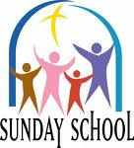Attention Sunday School**

Our Christmas Program is fast approaching! We will be holding a rehearsal with pizza on Friday, Dec. 9th at 5:30pm at the church. On Saturday, Dec. 10th we will be holding a bake sale from 9am-2pm at the Dalton Community Center. If you would like to bake or donate goods, you can drop them off Friday at the rehearsal or Saturday morning between 7 and 9am. Our Christmas Program will be held during the 10:30 service on Sunday, Dec. 11th, and will be followed by a lunch.

**Military Service Members**

Christmas is a wonderful time to remember and thank our military service members!

SGT Brandon Wilke

4356 Holland St

Apt B

Fort Campbell, KY 42223

**Thank You**

A big thank you to Jerry and Bob Thormondson for helping with leaf relocation and gutter clean-up at the parsonage.

Thanks to Sara Hage and Christinia Saurer for putting together our Trunk-or-Treat goody bags and Sunday School invitations.

Thanks to Pat Welch, Lori and Dean Thorsen, Kadie and Ashley Schroeder and Luke Zelie for costuming and decorating your trunks. It was a lot of fun!

**New Council Members**

OSTML is looking for three new Council members in January. Think about it… Pray about it…

**Church Funnies**

Seen in church bulletins:

Scouts are saving aluminum cans, bottles, and other items to be recycled. Proceeds will be used to cripple children.

Ladies, don’t forget the rummage sale. It’s a chance to get rid of those things not worth keeping. Bring your husbands.

Don’t let worry kill you off- let the church help!

The ladies of the Church have cast off clothing of every kind. They may be seen in the basement on Friday afternoon.

**OSTML Worship Leaders for December:**

**Team Leaders:** Eric & Kathy Mounts, Steve & Nancy Moss

**Altar Guild:** Nancy Moss

**Communion Ass’ts:** Dec. 4- Mitchell Sterns

Dec. 25 Jerry Thormodson

OS-TML News

**

*"He guides me in the right paths for his name's sake"   
Psalm 23:3*

Joy and peace to all this advent season. "He will come in glory" Luke 21:25–28. As we enter these weeks of Advent, this time is used in anticipation and hope of Christ coming. To anticipate is to look forward to, to be ahead of doing.   
  
Although there is much commercialism and secularism during this holy time, Christians have high hopes and expectations at this joyous time. Some of the ways preparations are accomplished for Christmas are: we are called to pray, fast, and share our gifts. During this time of sharing, we experience happiness, festivity, and the beauty of religious decorations and other traditions such as the Advent Wreath and Nativity scenes. Some positive points for all is: reduce the stresses of find the perfect gift, eating healthy foods, consuming less alcohol, reducing role overload (whatever that means for you) and increasing exercise. Coping at Christmas can be more positive by planning ahead, eating less fattening foods, keeping quiet time to pray, going to church, buying gifts with in your financial means, staying healthy by eating and sleeping regularly, and limiting exposure to colds and flu.   
  
May this be a season of peace, if not Joy – a season of healing and love, knowing that others care and remember. And may you feel God's gentle care and healing touch through the gift of family and friends.

Peggy

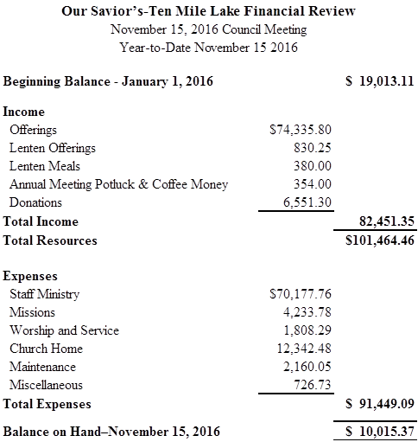

****

**DECEMBER:**

1. Teresa Akerman

2 Lorraine Bonnichsen

2 Parker Ecker

12 Betty Funkhouser

19 Chris Ecker

23 Ellie Walvatne

24 Jacob Bigelow

25 David Schroeder

27 Julie Olson

30 LuAnn Reger

31 Ella Sonmor

**ADVENT DECORATING**

Thanks to everyone who came out to help decorate Our Savior's-Ten Mile Lake Lutheran Church.

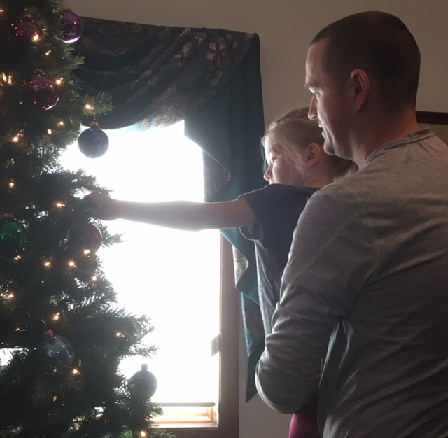  
Kelly and Aubrey Walvatne

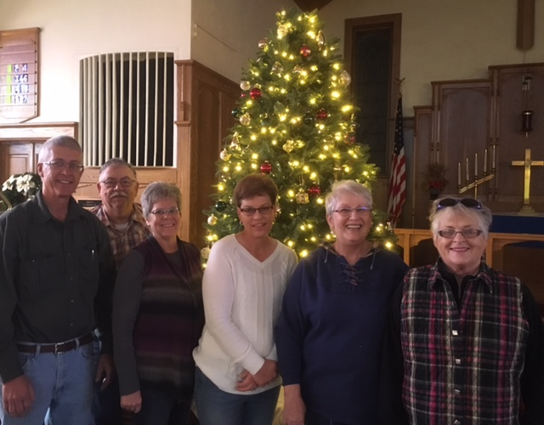  
Jerry Thormodson, Pat Welch, Danette Thormodson, Nancy Moss, Peggy Lien, Joan Swensrud (not pictured: Teresa Akerman, Steve Moss, Kelly and Aubrey Walvatne, and Pastor Matt)

**Our Savior’s Lutheran Church**

US Postage Non-Profit Org

**PO Box 158** PAID

Dalton, MN 56324 Permit No. 5

**RETURN ADDRESS REQUESTED**

**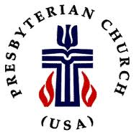 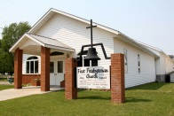**

**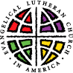 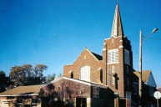**

**\_\_\_\_\_\_\_\_\_\_\_\_\_\_\_\_\_\_\_\_\_\_\_\_\_\_\_\_\_\_\_\_\_\_\_\_\_\_\_\_\_\_\_\_\_\_\_\_\_\_\_\_\_\_\_\_\_\_\_**

**SHARED MINISTRY STAFF**

Pastor Matthew Zelie

Office Administrator: Jessica Zelie

OS-TML Office & Pastor’s Study: 589-8454 - 105 S. Central Ave.., PO Box 158, Dalton, MN 56324

First Presbyterian Church: 747-2744 - 202 Nelson St., PO Box 14, Ashby, MN 56309

Office Email – [ostml@prtel.com](mailto:ostml@prtel.com)

WORSHIP SCHEDULE

SUNDAY MORNING WORSHIP ~ TIME CHANGES

**9:00 am – Our Savior’s-Ten Mile Lake Worship**

Holy Communion the 1st and 4th Sunday

Coffee Fellowship – 3rd Sunday

**10:30 am – First Presbyterian Worship**

Holy Communion the 1st Sunday

**Make Worship A Part of Your Life**

**December 2016**

|  |  |  |  |  |  |  |
| --- | --- | --- | --- | --- | --- | --- |
| **Sunday** | **Monday** | **Tuesday** | **Wednesday** | **Thursday** | **Friday** | **Saturday** |
|  |  |  |  | 1  6pm Session Mtg (Ashby) | 2 | 3  Matt and Jess’ Open House 11-4  C:\Users\OSTML\AppData\Local\Microsoft\Windows\Temporary Internet Files\Content.IE5\D74GJ6P8\Christmas_Wreath[1].jpg |
| 4  *(Second Sunday in Advent-Blue)*  9:00am OS-TML H.C. Worship  10:30am First Presb H.C., Worship | 5  (Pastor Matt at Advent Retreat) | 6  (Pastor Matt at Advent Retreat)  Parish Nurse 10-12  **NO Brown Bag in December** | 7  9am Quilting (OSTML)  7pm Advent Service (Dalton) | 8 | 9 | 10  10am Kelli Meehl Wedding Shower (OSTML)  Santa Days (Dalton) |
| 11  *(Third Sunday in Advent-Blue)*  9:00 am First Presbyterian Worship  10:30 am OS-TML Worship & Sunday School Program  *(lunch after service)* | 12 | 13  Parish Nurse 10-12 | 14  9am Quilting  WELCA Potluck 12pm  7pm Advent Service (Ashby) | 15  7pm Council Mtg (Dalton) | 16 | 17 |
| 18  *(Fourth Sunday in Advent-Blue)*  9am OS-TMLWorship  10:30am First Presb, Worship & Sunday School Program | 19 | 20  Parish Nurse 10-12  Pastor Matt at New Pastor’s Training 11-1  2:30 Broen Home Communion  Newsletter deadline! | 21  7pm Advent Service (Dalton) | 22 | 23 | 24  5pm Christmas Eve Service (OSTML) |
| 25  *(Christmas Day-White)*  9:00am OS-TML H.C. Worship  10:30am First Presb. H.C. Worship | 26 | 27  Parish Nurse 10-12  12 pm Brown Bag  2:30 pm Broen Home | 28  9am Quilting  NO CONFIRMATION | 29 | 30 | 31 |