**First Presbyterian Session Members**

Barb Dewey – Clerk of Session

Troy Johnson – Elder (2)

Dave Williams – Elder (1)

Betty Lou Cravens- Elder (2)

Heidi Hoff – Elder (1)

Judy Helle – Elder (3)

Jim Rylander – Elder (3)

Jim Risbrudt – Treasurer

**Shared Ministry Council**

Jim Borgrud – Chm. (3)

Val Martin- Vice Chm. (3)

Barb Dewey – Secretary (2)

Jim Risbrudt – Financial Secretary (1)

Dave Olson (1)

Pat Welch (2)

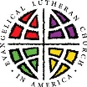

**OS-TML Church Council**

President – Pat Welch (1)

Vice Pres. – Joyce Samuelson (1)

Secretary – Christina Saurer (1)

Treasurer – Debbie Wilke (1)

Deacons – Teresa Akerman (2)

Mitchell Sterns (3)

Jerry Thormodson (3)

Trustees - Jim Borgrud (2)

Kelly Walvatne (2)

Brian Hansel (3)

**Women of the ELCA Co-Presidents**

Karen Nelson

Shirley A. Frigaard

**Board of Education**

Christina Saurer (2)

Sara Hage (1)

Ashley Lee (1)

**Endowment Fund Board**

Julie Olson (1)

Karen Nelson (1)

Lyle Skinnemoen (2)

Deb Thormodson (3)

**Our Savior’s Cemetery Board**

David Schroeder, Sexton (1)

Kyle Frigaard

Dean Thorsen

Gaylan Thormodson

Larry Sonmor

**INDEX**

Page 1 Minister’s Musings

Pages 2-3 First Presb. News

Pages 3-4 Shared Ministry News

Pages 4-6 OS-TML News

Calendars

**The Minister’s Monthly Musings –January, 2017**

A new calendar year stretches before us. A year that will encompass joys and heartaches, progress and setbacks, challenges and respite, as yet unseen. As I write this, we are four days out from Christmas Day. But it’s not carols playing in my head but the Byrds’ rock ‘n’ roll tune “Turn, Turn, Turn.” Of course, those song lyrics are straight out of the book of Ecclesiastes where Qoheleth—the narrator whose name means “collector of wisdom”—puts it this way: “To everything there is a season, and a time to every purpose under heaven: A time to be born, and a time to die; a time to plant, and a time to pluck up that which is planted […] a time to weep, and a time to laugh; a time to mourn, and a time to dance […] that every man should eat and drink, and enjoy the good of all his labour, it is the gift of God.” (Eccles. 3:1-2; 4; 13 KJV).

Each of us is called to labor in service to God and others. And Qoheleth calls these vocations gifts. Our families, jobs, volunteer work, care for neighbor—all of it a gift, a trust, and, yes, at times a great burden. Yet as we embark on this new calendar year, we do so with confidence because Christ goes with us, to draw us onward and to strengthen us. As that Irish prayer popularly attributed to Saint Patrick puts it: “Christ with me, Christ before me, Christ behind me, Christ in me, Christ beneath me, Christ above me, Christ on my right, Christ on my left, Christ when I lie down, Christ when I sit down, Christ when I arise …” This is what keeps you, me, and our Shared Ministry moving forward: that our Lord continues to offer provisions for the journey—his forgiveness in Holy Baptism; his life in bread and wine; his Holy Word in preaching; his presence through fellowship in the Body of Christ.

If you had a package waiting for you at the post office, wouldn’t you pick it up? If you won a meat raffle, wouldn’t you claim it? When we gather on the Lord’s Day, Christ Himself promises to be present (“where two or more are gathered in My name, there I am in the midst of them” Mt. 18:20). And Christ’s presence is our comfort, aid, and succor for in Him are righteousness, peace, and joy through the Holy Spirit (Rom. 14:17).

Now there are many other treasures of the faith as well, treasures to be unearthed in these pages as we dig into our common Reformation heritage and explore a different theological topic each month. This year marks the 500 year anniversary of the Protestant Reformation. According to tradition, on Oct. 31, 1517, Martin Luther—small-town Catholic priest, Augustinian monk, and seminary professor—nailed ninety-five points of debate to the door of All Saints’ Church in Wittenberg, Germany. This action sparked a religious movement that swept Europe and later the “New World,” challenging the church to return to its roots. For “reform,” not “innovation,” was the driving principle behind the men and women who sought to restore fidelity to apostolic faith and practice. Martin Luther and **Katherine von Bora,** John Calvin and **Jeanne d’Albret, Ulrich Zwingli and** Thomas Cranmer: without these reformers we would not have the Lutheran and Presbyterian churches that comprise our Shared Ministry.

I look forward to sharing with you some of the great insights of these reformers as we re-acquaint ourselves—or in some cases discover for the very first time!—our Reformation heritage together.

Happy New Year! May God strengthen you for the journey that is 2017.

In the name of the Father, and of the ☩ Son, and of the Holy Spirit. Amen.

Rev. Matthew Zelie †

First Presbyterian News

**Regular Session Meeting**

**December 1, 2016**

The regular Session meeting of the 1st Presbyterian Church of Ashby met 6 PM , December 1, 2016 at the church.  Those present were Moderator Rev.  Matthew Zelie, Ruling Elders Dave Williams, Heidi Hoff, Jim Risbrudt, Betty Lou Cravens, treasurer Jim Risbrudt, Clerk Barb Dewey and guest Jennifer Smith.  Absent were Troy Johnson and Judy Helle.  The meeting was called to order and opened in prayer by Moderator Rev. Zelie. The Shared Ministry Mission Statement was read together.

After examination the Session voted to accept Jennifer Smith into our church membership by Affirmation of Faith.

A quorum was present and docket voted approved.  The minutes from the last meeting were read and voted approved.   The treasurer’s report was given showing $3380.65 in the general fund and $18,931.26 in the various savings accounts were voted approved.

**Pastor’s Report:** November was a month of planning for Advent and special Services and working with Pastor Tom on Youth Group (which met twice) and the joint Thanksgiving Service Nov. 22 at Peace Lutheran.  The first Advent service was Nov.30 in Ashby. Preparation for baptism meeting with the Hokanson family.  Newsletter writing. Pastoral care included 4 home visits, 1 to hospital and one appointment at the office.  There were 5 Brown bag lunches with Psalm studies.  3 Confirmation classes.   Met with Ross Stone and Pastor John Lindholm of Presbytery Leadership for 6 month review on Nov 21 and all met with Session on Nov. 29.

**Communications:**  Presbytery notified us Per Capita due January 31, 2017 is $4,099.40 or $39.80 per active member.   The Session voted to make a $500 General Mission Pledge for 2017 Section A of Presbytery Mission Support.  A request from Presbytery re: neutral pulpit didn’t work for us in December.

**Committee Reports:  Buildings and Grounds**:  the furnace fix has been installed.

**Christian Education:** Sunday School Christmas Program is December 18.   We will have coffee before and cake after.

**Worship:** December 25 Christmas Day services with communion at Church at 10:30 AM.  No coffee that Sunday.  Our Savior’s Ten Mile Lake will have Christmas Eve services at 5 PM.

**Stewardship:** Heidi, Judy and Jim Risbrudt will review and prepare budget.   The Annual Meeting was set for January 15, 2017 and we will ask for switch of worship times to later service.

**Nominating Committee:**  Ruling Elder candidates have been found: Cindy Welch and Kyle Rylander.

The Session voted to accept all committee reports.

**Old Business:**   Starner Funds were voted to be distributed:  World Mission:  Pakistan Students-$730 and Presbytery of Mn Valleys mission $500.    Local Mission:   Grant County Food Shelf:  $350, Ashby School backpack program-$200, Caring Neighbors of Ashby-$100, Union Cemetery of Elbow Lake-$200, Pelican Lake Cemetery of Ashby-$200 and Peace/Grue Church Harvest Meal-$150.

**New Business:** Barb Dewey will meet with group of volunteers to set up Disciple list on December 28.

**Elder Training** done on Holy Communion. Old term for it is Eucharist meaning “thanksgiving”. Originally meant to be at each worship service--the recommendation of both the PCUSA and ELCA. But in most midwestern churches it is once or twice a month.  This is because historically the pastor only came to a church once or twice a month so churches couldn't commune more regularly. Roman Catholics believe the elements change in substance to the blood and body of Christ. Lutherans believe that there is bodily presence in, with, under the elements.   Presbyterians believe in the spiritual presence in the elements. All three traditions affirm--with most Christians--that Christ is really present in the bread and wine. Holy Communion is not something we do (mere remembrance) but a gift Christ gives us: himself and all His benefits.

The next meeting was set for January 9, 2017.  The meeting was adjourned and closed in prayer.

Moderator Rev. Matthew Zelie

Barbara Dewey, Clerk of Session



**January**

16th Robert Hutchings

19th Ron Breuer

21st Marjorie Boren

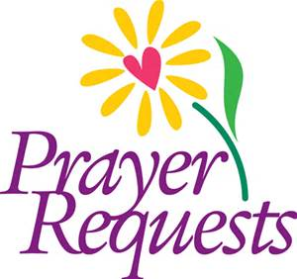

Ian Bertram, J.R. Caraway, Jon Heinrich, Brady Kruize, Jarod Johansen and All military personnel; Members and Friends: Delores Bullis, Marge Boren, Whitney Gramm, and Jim Karl.

First Presbyterian News

**Disciples for January:**

Jim & Gwyn Risbrudt

Jenny Tollefson

Tom & Terry Grover

Peter & Heidi Hoff

Kelsey Nordick

Mike & Lori Risbrudt

Lois Ellingson

Troy & DeEtte Johnson

Cari Ripley

Kathleen McNeely

**Per Capita**

Our Westminster Confession of Faith says, “all believers are, therefore, under obligation to sustain the ordinances of the Christian religion where they are already established, and to contribute by their prayers, gifts, and personal efforts to the extension of the Kingdom of Christ throughout the whole earth” (The Book of Confessions, 6.058).

Per capita for 2017 is $39.80. Members are encouraged to give before the January 31st deadline. This is a fundamental way in which all of the nearly 11,000 of the Presbyterian Churches (U.S.A.) are connected and participate in the work of the wider church.

Rooted in the covenantal nature of the Presbyterian church, per capita is the church's "community fund" whereby Presbyterians mutually share the costs of supporting the work of churches, commissions, general assembly, and elder training. Please consider paying your per capita share to support the work of Christ's Body at the global, regional and local levels. To God be the glory--great things He hath done AND is doing!



**Annual Meeting**

First Presbyterian will hold its annual meeting following a **10:30am** worship service on Jan. 15th.



Shared Ministry News

**CONFIRMATION!**

Confirmation is a two-year program that serves 7-9th graders in our Shared Ministry and focuses on learning about Christ, his Church, and the apostolic faith. Last year we studied the distinctive practices of Lutherans and Presbyterians but also the creeds and theology they share. This year we study the Reformation and Holy Scripture. Classes are held Wednesdays, 7-8 pm, at First Presbyterian or Our Savior’s-Ten Mile Lake. During the seasons of Advent and Lent, students are required to participate in the Wednesday night services in lieu of regular class time. If you have students interested in participating, please email me so that I can send along the sign-up/contact sheet and schedule.

Jan. 4 NO CONFIRMATION

Jan. 11 7pm Confirmation Ashby

Jan. 18 7pm Confirmation Dalton

Jan. 25 7pm Confirmation Ashby

Feb. 1 7pm Confirmation Dalton



**Service Time Change**

We are switching service times again! Starting **January 1**, First Presbyterian will hold worship at 9:00 Sunday morning, with the exception of Jan. 15, when OSTML will hold worship at 9am, and First Presbyterian will hold worship at 10:30, followed by their annual meeting.



**To Our Snowbirds**

Before you take wing for lower latitudes and warmer climes, please update the office with your address and schedule so you can continue to receive the monthly newsletter. Thanks!



**Thank You**

A big ‘thank you’ to Ross Stone and Pr. John Lindholm for conducting a “six-month check-in” on behalf of the Presbytery of MN Valley and also to the Presbyterian members of the Pastoral Nominating Committee and Session who attended this conversation about our church and its future. This will provide Session and Pastor Matt with leadership ideas and insight into direction for the church this coming year.

**Pastor Matt on Vacation**

Pastor Matt and Jess will be on vacation from Jan.1-Jan.8. Pastor Zinta Sundby will be conducting worship on Jan. 8 and on call for pastoral care. She can be reached at 218-770-8254.



**List of Homebound Members and Friends:**

**First Presbyterian Friends**

Delores Bullis

800 Spruce Ave

No. 22

Barrett, MN 56511

Bob Sanford

1821 N Park St.

Fergus Falls, MN 56537

Marge Boren

P.O. Box 287

Ashby, MN 56309

Verle Martin

C/O Good Sam.

105 Glenhaven Dr.

Battle Lake, MN 56515

Lee Moellmann

1000 Court Dr.

Morris, MN 56267

**Our Savior’s-Ten Mile Lake Friends**

Ella Sonmor

802 S. Mill St.

#103

Fergus Falls, MN 56537

Grace Simonson

16704 Co Hwy 33

Dalton, MN 56324

Sidney Skrove

418 E. Alcott

#204

Fergus Falls, MN 56537

Trevor Boe

120 Oriole Dr.

Fergus Falls, MN 56537

Betty Nelson

P.O. Box 273

Dalton, 56324

OS-TML News

**\*\*\*OSTML CHURCH COUNCIL MINUTES** for December will be included in the February newsletter.

**Prayer Requests:** Trevor Boe and Dale Helgeson.

**MINNEAPOLIS INSTITUTE OF ART EXHIBITION**

Mia would like to invite you to a special exhibition, ***Martin Luther: Art and the Reformation***. The exhibition runs from October 30-January 15. To reserve tickets, call 612-871-3000 or go online to [www.artsmia.org/luther](http://www.artsmia.org/luther)

**OSTML Worship Leaders for January:**

**Team Leaders:** Peggy Lien and Pat Welch

**Altar Guild:** Bonnie Borgrud

**Communion Ass’ts:** Jan. 1- Teresa Akerman

Jan. 29- Mitchell Sterns



OS-TML News

**

"Glory to God in the highest, and on earth peace, goodwill toward men." Luke 2:14.

While attending a high school Christmas concert the Sunday before Christmas, the theme and title of the program was "In Terra Pax" which is Latin for "peace on earth."

The idea of peace on earth is not new, in fact, the idea is as likely as old as humanity itself. But what is peace? What does it look like? Is it true that peace can mean the absence of conflict. Where there is no war, no hatred, nor fear, and where love abounds, there is peace. But this is not the only way we experience peace. To be at peace can mean to be confident, secure and powerful even in the face a great danger. There are people who live with illness. Their bodies may be ravaged by disease, and yet, they are at peace. Others may have difficult circumstances, and though their lives are rough, they are still secure. They may look powerless, yet live as though they are powerful. As we live our lives, the media reports news of violence and unrest throughout our planet. What can we do? Perhaps the idea of thinking globally and acting locally might be our best approach. Perhaps knowing that are small acts of good, day to day, make a difference and can have lasting effects; both here and beyond our reach.

It is my sincere wish that you find peace in your world in 2017.

"Depart from evil, and do good; seek peace, and pursue it." Psalms 34:14

Peggy



**Thank you to the following people who donated poinsettia plants in memory of their loved ones:**

Steve & Debbie Wilke

Pat Welch

David & Mary Jo Schroeder

Eldon & Karen Nelson

Pat Boe

Betty Funkhouser

Steve & Nancy Moss

Daryl & Shirley Frigaard

Loren & Debbie Thormodson

Ryan & Darcy Risbrudt

Gene & Myrna Hanson

Jerry & Danette Thormodson

Jim & Bonnie Borgrud

Peggy Lien

Loren & Shirley Frigaard

Charles & Joan Swendsrud

Dean & Barb Ness

Mary Moebius

Eric & Kathy Mounts

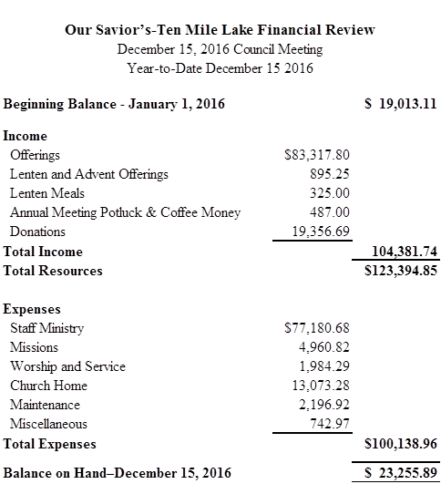



JANUARY:

6 Steve Moss

10 Dain Nelson

13 Don Moen

14 Carl Samuelson

15 Shaun Anderson

17 Steve Anderson

17 Gretchen Ness

18 Sharen Anderson

18 Ashley Schroeder

27 Lois Eggum

30 Matt Sterns



**THANK YOU**

Thank you to everyone for the generous gifts we’ve received this Christmas season!

Sincerely,

Matt, Jess, and Luke

A big thank you to the altar guild for their service this past year. Everyone did a great job and we appreciate all you work. The lineup for 2017 will remain the same. If there are any conflicts, please call Mary Jo or Bonnie.

**2017 Altar Guild Team Members**

January-------------------------------------Bonnie Borgrud

February-----------------------------------Debbie Thormodson

March---------------------------------------Kathy Mounts

April------------------------------------------Myrna Hanson

May-------------------------------------------Joan Helgeson

June----------------------------------------Karen Nelson

July-----------------------------------------Marie Moen

August-------------------------------------Sara Hage

September-------------------------------Karen Hansel

October-----------------------------------Barb Ness

November--------------------------------Mary Jo Schroeder

December--------------------------------Nancy Moss

Alternates--------------------------------Betty Funkhouser,

Danette Thormodson

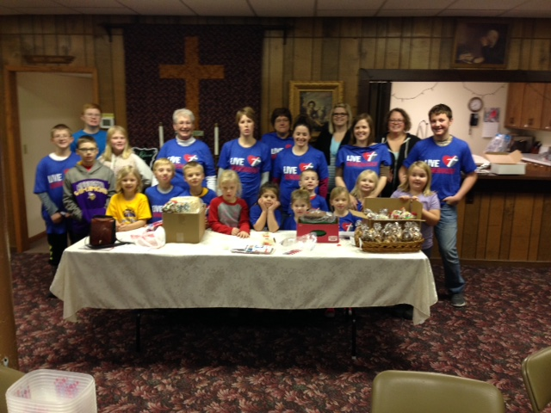

Preparing for Sunday School Bake Sale with help from Thrivent.

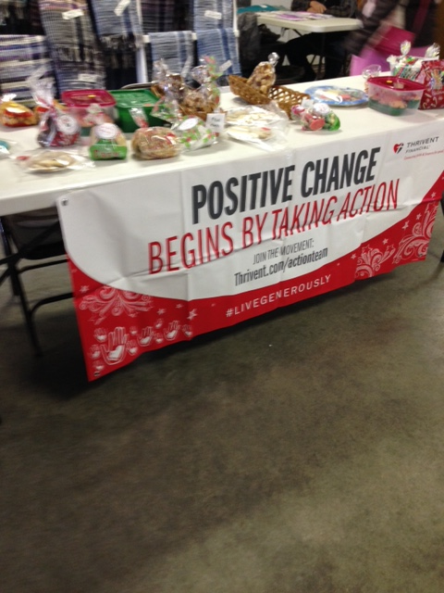

Sunday School Bake Sale at Santa Days.

**Our Savior’s Lutheran Church**

US Postage Non-Profit Org

**PO Box 158** PAID

Dalton, MN 56324 Permit No. 5

**RETURN ADDRESS REQUESTED**

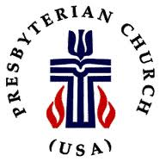 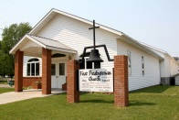

 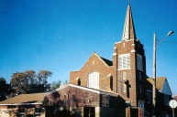

**___________________________________________________________**

**SHARED MINISTRY STAFF**

Pastor Matthew Zelie

Office Administrator: Jessica Zelie

OS-TML Office & Pastor’s Study: 589-8454 - 105 S. Central Ave.., PO Box 158, Dalton, MN 56324

First Presbyterian Church: 747-2744 - 202 Nelson St., PO Box 14, Ashby, MN 56309

Office Email – [ostml@prtel.com](mailto:ostml@prtel.com)

WORSHIP SCHEDULE

SUNDAY MORNING WORSHIP ~ TIME CHANGES

**9:00 am – Our Savior’s-Ten Mile Lake Worship**

Holy Communion the 1st and 4th Sunday

Coffee Fellowship – 3rd Sunday

**10:30 am – First Presbyterian Worship**

Holy Communion the 1st Sunday

**Make Worship A Part of Your Life**

**January 2017**

|  |  |  |  |  |  |  |
| --- | --- | --- | --- | --- | --- | --- |
| **Sunday** | **Monday** | **Tuesday** | **Wednesday** | **Thursday** | **Friday** | **Saturday** |
| 1  *(First Sunday After Christmas-White)*  9:00am First Presb. H.C. Worship  10:30am OS-TML H.C. Worship | 2  **Pastor Matt on vacation 1/2-1/8, Pastor Zinta covering** | 3  Parish Nurse 10-12  NO BROWN BAG | 4  9am Quilting (OSTML)  NO CONFIRMATION  Peace-Grue Youth Group 7:30pm Ness Residence | 5 | 6  **Deadline for OSTML Annual Report Materials** | 7 |
| 8  *(The First Sunday After Epiphany-White)*  9:00am First Presb. Worship  10:30am OS-TML Worship  *(Pastor Matt Away, Pastor Zinta covering)* | 9  6pm Session Meeting (Ashby) | 10  Parish Nurse 10-12  12pm Brown Bag | 11  9am Quilting (OSTML)  7pm Confirmation (Ashby) | 12 | 13 | 14 |
| 15  *(The Second Sunday After Epiphany-Green)*  **9:00am OS-TML Worship**  **10:30am First Presb. Worship**  *(First Pres. Annual Meeting after service)* | 16 | 17  Parish Nurse 10-12  12pm Brown Bag | 18  9am Quilting (OSTML)  7pm Confirmation (Dalton)  Peace-Grue Youth Group 7:30pm Ness Residence | 19 | 20 | 21 |
| 22  *(The Third Sunday After Epiphany-Green)*  9:00am First Presb. Worship  10:30am OS-TML Worship  *(OSTML Annual Meeting and Potluck after service)* | 23 | 24  Parish Nurse 10-12  12pm Brown Bag  Newsletter deadline! | 25  9am Quilting (OSTML)  7pm Confirmation (Ashby) | 26 | 27 | 28 |
| 29  *(The Fourth Sunday After Epiphany-Green)*  9:00am First Presb. Worship  10:30am OS-TML H.C. Worship | 30 | 31  Parish Nurse 10-12  12 pm Brown Bag  2:30 pm Broen Home |  |  |  |  |