**First Presbyterian Session Members**

Barb Dewey – Clerk of Session

Troy Johnson – Elder (2)

Dave Williams – Elder (1)

Betty Lou Cravens –Elder (2)

Heidi Hoff – Elder (1)

Judy Helle – Elder (3)

Jim Rylander – Elder (3)

Jim Risbrudt – Treasurer

**Shared Ministry Council**

Jim Borgrud – Chm. (3)

Val Martin- Vice Chm. (3)

Barb Dewey – Secretary (2)

Jim Risbrudt – Financial Secretary (1)

Dave Olson (1)

Pat Welch (2)

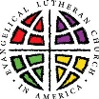

**OS-TML Church Council**

President – Pat Welch (1)

Vice Pres. – Joyce Samuelson (1)

Secretary – Christina Saurer (1)

Treasurer – Debbie Wilke (1)

Deacons – Teresa Akerman (2)

Mitchell Sterns (3)

Jerry Thormodson (3)

Trustees - Jim Borgrud (2)

Kelly Walvatne (2)

Brian Hansel (3)

**Women of the ELCA Co-Presidents**

Karen Nelson

Shirley A. Frigaard

**Board of Education**

Christina Saurer (2)

Sara Hage (1)

Ashley Lee (1)

**Endowment Fund Board**

Julie Olson (1)

Karen Nelson (1)

Lyle Skinnemoen (2)

Deb Thormodson (3)

**Our Savior’s Cemetery Board**

David Schroeder, Sexton (1)

**INDEX**

Page 1 Minister’s Musings

Pages 2-3 First Presb. News

Pages 3-4 Shared Ministry News

Pages 4-7 OS-TML News

Calendars

**The Minister’s Monthly Musings –October, 2016**

**The Law of Prayer is the Law of Faith**

**Part One**

I don’t know about you, but I love the fall. And I have as far back as I remember.

That bloom of fiery leaves. The whiff of wood smoke. The rusty tassels of dried cornstalks. It brings me back to the autumn rituals of my youth: the square dances, apple picking, pumpkin pie baking, and all the gatherings celebrating harvest. And yet lurking underneath it all: a fresh urgency to our tasks as we anticipate the coming cold.

In many ways, learning to walk by faith is about this double vision—looking back and ahead at the same time. A people keeping the horizon in view. Called to fix our eyes on Christ. To run with diligence the race set before us. To look to the hope of glory. To await the Second Coming and prepare for the One who will make all things new.

But we are also people of the Book. Formed by the tradition of the Apostles. Our lives built on the faith and practices of others. These are the daily rhythms of confession, repentance, prayer, study, meditation, and acts of charity. The weekly ritual of assembling on the Lord’s Day. And then the yearly liturgical seasons marking the central events in salvation history: Advent, Christmastide, Lent, Eastertide, Pentecost , and so on. Reliving the church’s seasons every year, we focus on a different aspect of God’s work in the world. We recall God’s faithfulness to His people Israel. We celebrate His goodness in sending Jesus. And we give thanks for the Holy Spirit who binds the church—past, present, and future—into one Body with Christ its head.

Just as our families gather around the table to celebrate birthdays and anniversaries, sharing the same stories again and again, so too does the church. Through ritual and story, God feeds us and strengthens us, forming us into the family of Christ. Many churches have gotten away from following the ancient Christian calendar. But as our forebears knew well, in a world that demands more of our allegiance every day, one of the ways we resist is by submitting our secular calendars to a higher time-keeper: ordering our lives around God and His Kingdom.

In the first three centuries, Christians assembled on the first day of the week. But unlike in our culture, this was no “weekend” for rest and leisure. Sunday was a normal work day! And many of these early Christians were slaves who snuck away from their “place of employment” in the early morning or late night at great peril to themselves and their families. What I’ve often wondered is: What did they understand about the Lord’s Day that many Christians today do not?

For these early Christians, this wasn’t about belonging to a social club, being a good citizen, or having access to the local gossip. (In the eyes of the Roman Empire, it was more like being in a terrorist cell!) But our forebears in the faith understood that confessing Christ—not Caesar—as Lord could mean the difference between life and death. They believed that they could NOT BELIEVE without the grace-imparting provisions of Christ’s Word and Sacrament. And they trusted that these divine gifts were forming them into the kind of people Christ created them to be.

With the celebration of our Lutheran and Presbyterian heritage this month (Oct. 30th is Reformation Sunday, a day we traditionally wear red), I invite you to offer prayers for our Sunday School programs, Confirmation classes and Sunday gatherings: that through the word and worship, liturgy and prayer, God would continue to re-form us. That being inspired by the witness and practice of Christians past, we might be faithful followers in this season and the next. To God be all glory, honor and praise!

In the name of the Father, and of the ☩ Son, and of the Holy Spirit. Amen.

Rev. Matthew Zelie †

First Presbyterian News

**Regular Session**

September 12, 2016

The regular Session meeting of the 1st Presbyterian Church of Ashby met at 6 PM, September 12, 2016 at the church.   Those present were Moderator Rev. Matthew Zelie, Jim Rylander, Judy Helle, Betty Lou Cravens, Troy Johnson, Heidi Hoff, treasurer Jim Risbrudt, and Clerk Barb Dewey.  Dave Williams was absent with excuse.  The meeting was opened in prayer by the Moderator Pastor Zelie.  The Shared Ministry Mission Statement was read together.   A quorum was present.  The docket was amended and approved.  The minutes of the previous meeting were approved after a date typo corrected to vacation October 20-26 th.

Jim Risbrudt presented the treasurer’s report showing $2108.01 in the General Fund checking account and $17,838.05 in the various savings accounts.  Memorials were received in honor of Gloria Williams. The report was voted approved.

**Pastor’s Report:** The funeral for Gloria Williams was held August 30, 2016 at the church.  Visitation and prayer service August 29.

Communion celebrated Sunday, September 4, 1016 with Pastor Zelie and 35 communicants.

Report was given by Pastor Zelie on the Presbytery meeting in Brown’s Valley on August 8th, which he also reported in this month’s newsletter.  He participated in the VBS held here August 15-18, made 10 Presbyterian pastoral calls, and met with Alexis Rylander in planning Sunday School, oriented Jess Zelie to office responsibilities, Broen Communion services August 23 and planned confirmation.

**Committee Reports:** Shared Ministry: The session voted to concur with the Shared Ministry request to have the active confirmed membership number for the year’s budget plans to be determined on October 31st of the year.   The budget will also be adjusted due to the savings in pension costs at this time.

**Buildings and Grounds:** The Session voted to have Wayne Stierlen install a insert to fix the problems in the furnace for estimate of $780.   Troy will contact Wayne.   The Session voted to not keep a couch donated by Gloria Williams’ family.   Church insurance update letters were presented.

Christian Education:  Sunday School begins September 18 with Lex Rylander and Deb Otto leading.  The Session had voted permission they repaint the classrooms.  Confirmation class begins October 21.

**Worship:**  Ashby services are at 10:30 Am for these 4 months.  OSTML at 9 AM.  Pastor Zinta Sundby will be doing services and pastoral care for Pastor Zelie’s vacation October 20-26.

**Old Business:** New member recognition still pending.  Pastor Zelie researching answers to copying music.

**New Business:** The Session voted Pastor Zelie’s requested vacation times of: December 5-6, 2016 (continuing ed), December 26-Jan.1, 2017 or Jan 2-8, 2017 (depending on coverage), May 1-7, 2017, July 29-Aug 6, 2017 and October 9-15, 2017 or 16-22, 2017 (depending on coverage).

   Peace-Grue Churches have invited us in discussion about starting a young adult ministry.  Heidi Hoff agreed to join Pastor Matt in this discussion with Pastor Tom Olson.

     The Session voted “no” to the maps of Ashby by Julie Tettig Design.

**Elder Training:** Pastor Zelie introduced a series on “What Presbyterians do not believe”.   Presbyterians do not believe in “Decision Theology” -sinners prayer, saved by good works.  Presbyterians believe the “Ladder Theology”-that salvation comes to us by the grace of God (Eph. 2:8).  A free gift of God.  God chose us.

The next meeting will be Tuesday, October 4, 2016, at 6 PM.  The meeting was adjourned and closed with prayer.

Moderator Rev. Matthew Zelie Barbara Dewey, Clerk of Session



**October**

9th Dennis Helle

10th Joyce Hirning

19th Cliff Martin

23rd Darla Kilker

29th Judy Bertram

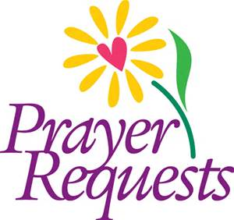===================================

Ian Bertram, J.R. Caraway, Jon Heinrich, Brady Kruize, Jarod Johansen and All military personnel; Members and Friends: Delores Bullis, Marge Boren, Whitney Gramm, Willie Kilker, and Richard Hagen.

Prayers and Sympathy for the family of Wally Bullis who passed away on Sept. 25th.

First Presbyterian News

**Disciples for October:**

Judy and Wayne Stierlen

Ron and Vonnie Breuer

Bob and Donna Grover

Bob and Dona Lou Hutchings

Russ and Barb Dewey



Fall Supper!

Mark your calendars! First Presbyterian will host its annual Fall Supper on Oct. 26th!

**Mark your calendars!!**

The Sunday school kids will be singing during the 10:30 church service October 16th. (3 songs) We will have Sunday school like normal at 9:30 beforehand.



The Christmas program will be December 18th at 10:30. More info will be provided as the date gets closer!

Shared Ministry News

**CONFIRMATION HAS BEGUN!**

Confirmation is a two-year program that serves 7-9th graders in our Shared Ministry and focuses on learning about Christ, his Church, and the apostolic faith. Last year we studied the distinctive practices of Lutherans and Presbyterians but also the creeds and theology they share. This year we study the Reformation and Holy Scripture. Classes are held Wednesdays, 7-8 pm, at First Presbyterian or Our Savior’s-Ten Mile Lake. During the seasons of Advent and Lent, students are required to participate in the Wednesday night services in lieu of regular class time. If you have students interested in participating, please email me so that I can send along the sign-up/contact sheet and schedule.

Wed. Sept. 21…………………Confirmation in Ashby, 7pm

Wed. Sept. 28………………..Confirmation in Dalton, 7pm

Wed. Oct. 5…………………….Confirmation in Ashby, 7pm

Wed. Oct. 12………………….Confirmation in Dalton, 7pm

Oct 19 and 26…………………Confirmation Off

**Looking for volunteer opportunities?**

**Check out the United Way of Otter Tail County! The UWOTC coordinates volunteer needs for a variety of non-profit organizations here in our county! Check them out at uwotc.org or by calling 218-736-5147.**



**Fall Festival**

First Lutheran Church in Battle Lake is holding their Fall Festival on Saturday, October 8th from 9am-1:30pm.

**Blood Drive**

****Battle Lake Lions is sponsoring an American Red Cross Blood Drive on Tuesday, October 18th from 12:30-6:30pm at First Lutheran Church in Battle Lake. Please bring a photo ID.

**PASTOR’S VACATION**

Pastor Matt will be on vacation October 20th-26th. Pastor Zinta Sunby will be leading worship on Sunday, October 23rd and available for pastoral care while Pastor Matt is away. Pastor Zinta can be reached on her cell at 218-770-8254.

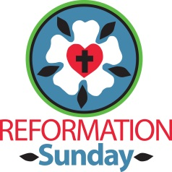

On **Sunday, October 30th** we will celebrate the Reformation. It is traditional to wear red!

**PASTOR’S BOUNDARY TRAINING REPORT**

Did you know that clergy have twice the rates of depression (1 in 4) compared to the general population (1 in 8)? That they have the highest death rate from heart disease of all professions? That they have much higher rates of obesity than the rest of the population? Or that 50% of clergy experience severe on-going stress due to their vocation, 20-40% report moderate to severe burnout, and 40% report moderate to severe financial stress owing to large seminary debt? These and other factors contribute to a staggering burnout rate among new clergy (50% of pastors drop out of ministry within 5 years of ordination.)  And yet: clergy score highest among all professions for being happiest with their jobs! Trying to reconcile these statistics can make your head hurt.

These were some of the things I learned on Set. 13 when I attended a sobering—but very instructive—boundary training event in Spicer, MN, hosted by the Presbytery of MN Valleys. Most denominations require ordained clergy to attend boundary training events every few years as continuing education. Here we learn about safe counseling practices, stress management, social media guidelines, sexual misconduct avoidance and reporting, and a host of other topics oriented toward helping clergy establish, maintain, or recover healthy boundaries. These boundaries (defined as the limit of one’s responsibility, power and influence) protect or restrict time management, emotional investment, interpersonal communication, family life/work balance, to name just a few of the areas touched on in our training.

I found this to be one of the most honest and helpful seminars in my six years of attending boundary workshops. It was great to learn from senior clergy with long years of experience in ministry as well as a counselor with insight into the psychological issues in play for pastors. The call to ordained ministry is a great privilege—but the demands on oneself, one’s spouse and family are great as well. I was grateful for an opportunity to reflect on difficult ministry questions in a safe and welcoming environment and thank the Presbytery of MN Valleys for making this possible.

-Pastor Matt

**NORTHWESTERN MN SYNOD RETREAT REPORT**

Due to Zelie family illness, I was unable to attend the retreat this year. The focus was on preaching.

–Pastor Matt

OS-TML News

**OSTML CHURCH COUNCIL MINUTES**

Our Savior's-Ten Mile Lake Church Council met Sept. 13, 2016 at 7:00 pm

Members Present: Pat Welch, Joyce Samuelson, Debbie Wilke, Brian Hansel, Jerry Thormodson, Teresa Akerman, Kelly Walvatne, Pastor Matt

**Devotions**: Jerry

The mission statement was read in unison.

**Secretary's Report:** Report was read by council. August 9th minutes were accepted with one change: Under old business, *Lenten offering number should have read $492.49  (not $429.49).*

**Treasurer's Report:** Presented with a balance of $12,628.08 with some outstanding bills.

**President's Report:** Nothing to report.

**Minister's Report:** July admitted of only one day free from church responsibilities to spend with family which made our week of camping at the start of August a great blessing! I will be looking at adjusting my schedule Sept-Oct so that my ministry hours better reflect the hours I am contracted for. This will allow me more down time to spend with family and help me be more effective in ministry and service. I am thankful to have Jess learning the ropes in the office as she steps into Shared Ministry administration. This month I attended Council (8/9); made 4 hospital visits and 15 office or home visits; I met with Pastor Mark Johnson to discuss Threshing Community Service; participated in four days of Shared Ministry VBS at First Presbyterian (8/15-18); and led Broen Home Service (8/23); Jess and I spent three days decluttering and organizing the office; and I met with Ashley Lee to discuss Sunday School and the future of youth ministry at OSTML.

**Trustee's Report:** Jim signed contract for propane at $0.99 per gallon and reminded us we still have propane credit on our old contract too; Jim has also been trying to find paint to match exterior church wall where weathering has left paint faded and cracking.

**Deacon's Report:** Jerry will serve communion on Oct 2nd and Teresa will serve on Oct. 23rd.

A motion to accept the reports as presented was made by Kelly and seconded by Brian.

**Old Business:** Discussion on where to give our Lenten offering in amount of $492.49. Kelly suggested we give some of this money to the food shelf. Jerry made a motion to donate $250 to the Fergus Falls food shelf given that with fewer Coffee House Sundays (and CH offerings) our giving to the food shelf is way down this year. Kelly seconded the motion.

**New Business:** Re: Shared Ministry Council, there is $33, 989.93 in the Shared Ministry budget. Shared Ministry has discussed ways to reduce this number. Some members felt that this surplus should be used in charitable giving; others that this money should be split according to our Shared Ministry percentages and held in each church account with recommendation from Shared Ministry that this money be used for charitable giving. Other members felt that the budget should simply be adjusted in January to bring this balance down (a balance that reflects our savings in pension costs). Also, the Shared Ministry requested that Council share the active confirmed membership number for the year’s budget plans to be determined on October 31st of the year. Pastor Matt and office admin. Jess will work on these numbers priors to the Shared Ministry meeting in October. Pat was happy to report that Jess is staying on as office admin. Pastor Matt shared possible vacation dates for the next year which were approved by Council: December 5-6, 2016 (continuing ed), December 26-Jan.1, 2017 or Jan 2-8, 2017 (depending on coverage), May 1-7, 2017, July 29-Aug 6, 2017 and October 9-15, 2017 or 16-22, 2017 (depending on coverage). Pastor Matt also shared that Peace-Grue Churches have invited us in discussion about starting a young adult ministry. The Council also decided not to invest in more maps by Julie Tettig Design. Jess was also tasked with putting together colored squares to fit on our hymn board with colors (dark blue and lime green) denoting which hymnal to be used for congregational singing.

**Next Meeting:** Oct. 10, 2016, devotions to be led by Pat Welch

The meeting closed with prayer by Pastor Matt and the Lord's Prayer was recited in unison.

Meeting adjourned at 7:55

Special thanks to Joyce Samuelson, designated secretary, for her excellent note-taking at our meeting!

Prayer Requests: Marie Cox, Donna Behrens, Dawson Rude, and Dale Helgeson.

**MINNEAPOLIS INSTITUTE OF ART EXHIBITION**

Mia would like to invite you to a special exhibition, ***Martin Luther: Art and the Reformation***. The exhibition runs from October 30-January 15. To reserve tickets, call 612-871-3000 or go online to [www.artsmia.org/luther](http://www.artsmia.org/luther).



OS-TML News

*"He guides me in the right paths for his name's sake"   
Psalm 23:3*

Fall is my favorite time of the year.  I've always thought of it as a start of so many new things such as school starting, Sunday School resuming, the season turning from summer into fall, the leaves changing colors and the feel of cooler weather. I so enjoyed and still do enjoy shopping and getting "new supplies for school". It was as if all the notebooks were just waiting for me create and learn. These days I find I'm still excited to learn new things and try to do so every day.  
  
Advance Care Planning: Knowing your voice is heard when making decisions about healthcare is important. Advanced care planning is the process of preparing for a time when you may not be able to make your own medical decisions. The best time to make these decisions is when you're able to make your own choices. The process of advanced care planning involves conversations throughout life about your values, beliefs and goals for future healthcare. Advance care planning conversations focus on your health care goals and what is important to you.  
• As you get older, goals, values and priorities often change.   
• give yourself and others peace of mind. Plan ahead while you are able.   
  
Start by thinking about what is important to you. Talk with your loved ones to share your thoughts. Even if you feel close to loved ones, they may not know what you want unless you tell them. The goal of advanced care planning is to help others understand what healthcare choices you would make if you could not communicate.  
  
Look for information on the showing of the PBS Frontline Special featuring Dr. Atul Gawande, author of the book ***Being Mortal.  The showing will be October 10 from 9 AM to 11 AM at Light and Life Auditorium at Broen Nursing Home, Fergus Falls.***

***I have information on advanced care planning and would be happy to meet with you individually.***

God bless,

Peggy

**OSTML Worship Leaders for October:**

**Team Leaders:** Loren and Debbie Thormodson, Dale and Joan Helgeson

**Altar Guild:** Barb Ness

OS-TML News

**Making History**

On Oct. 31, 2016, we will make history. Lutherans and Catholics from around the world will come together for the anniversary of the Reformation. The [Lutheran-Catholic commemoration](https://community.elca.org/page.redir?target=http%3a%2f%2fwww.elca.org%2fFaith%2fEcumenical-and-Inter-Religious-Relations%2fBilateral%2fJoint-Ecumenical-Commemoration&srcid=104085&srctid=1&erid=20593277&trid=7c460ec4-1e2c-43d2-be48-9d1c9f032079) will take place in Lund, Sweden, with a Common Prayer service led by Pope Francis, The Lutheran World Federation President Bishop Dr. Munib A. Younan and its general secretary, the Rev. Dr. Martin Junge.  
  
After 500 years, both Lutherans and Catholics share the joy for the positive elements of the Reformation, rejoicing together in the gospel and acknowledging that we are sent together as the body of Christ to serve the world. The joint commemoration witnesses to the reality that what unites us is more powerful than what divides us. This event is an opportunity to open doors to new possibilities, strengthen relationships, work together to promote peace, reconciliation and joint diaconal work around the world. As a sign of unity, Lutheran World Service and the Catholic agency, Caritas Internationalis, will commit to a Declaration of Intent, promising to work together in programs world-wide.  
  
You can be a part of this exciting moment in history.

* Pray for Christian unity, and commend and encourage continued local Lutheran-Catholic dialogue and engagement.
* Consider ways you or your congregation could support the joint ecumenical commemoration. [Gifts](https://community.elca.org/page.redir?target=https%3a%2f%2fcommunity.elca.org%2fjoint-ecumenical-commemoration-of-the-reformation&srcid=104085&srctid=1&erid=20593277&trid=7c460ec4-1e2c-43d2-be48-9d1c9f032079) are needed to help support this unprecedented event.
* Attend the event, register for updates and get notified when tickets become available at [lund2016.net](https://community.elca.org/page.redir?target=http%3a%2f%2fwww.lund2016.net%2f&srcid=104085&srctid=1&erid=20593277&trid=7c460ec4-1e2c-43d2-be48-9d1c9f032079).
* View the recorded service in the Lund Cathedral with a group in your congregation and consider inviting Catholic parishes to join. You can [download](https://community.elca.org/page.redir?target=http%3a%2f%2fwww.lutheranworld.org%2fsites%2fdefault%2ffiles%2fdtpw-lrc-liturgy-2016_en.pdf&srcid=104085&srctid=1&erid=20593277&trid=7c460ec4-1e2c-43d2-be48-9d1c9f032079) a template of the liturgy, Common Prayer, to follow along.
* Find resources to use in your congregation. The 2016 ELCA Churchwide Assembly commended these resources to the church: ["From Conflict to Communion,"](https://community.elca.org/page.redir?target=http%3a%2f%2fwww.lutheranworld.org%2fsites%2fdefault%2ffiles%2fFrom%2520Conflict%2520to%2520Communion%2520EN.pdf&srcid=104085&srctid=1&erid=20593277&trid=7c460ec4-1e2c-43d2-be48-9d1c9f032079) which is the basis for the joint commemoration and has a helpful [study guide](https://community.elca.org/page.redir?target=http%3a%2f%2fdownload.elca.org%2fELCA%2520Resource+Repository%2fFrom_Conflict_To_Communion_Study_Guide_3-13.pdf&srcid=104085&srctid=1&erid=20593277&trid=7c460ec4-1e2c-43d2-be48-9d1c9f032079) for local use; ["Declaration on the Way: Church, Ministry, Eucharist,"](https://community.elca.org/page.redir?target=http%3a%2f%2fdownload.elca.org%2fELCA%2520Resource+Repository%2fDeclaration_on_the_Way.pdf&srcid=104085&srctid=1&erid=20593277&trid=7c460ec4-1e2c-43d2-be48-9d1c9f032079) a pioneering ecumenical document whose statement of agreements was overwhelmingly received by the 2016 ELCA Churchwide Assembly; and the 1999 "[Joint Declaration on the Doctrine of Justification."](https://community.elca.org/page.redir?target=http%3a%2f%2fdownload.elca.org%2fELCA%2520Resource+Repository%2fJoint_Declaration_On_The_Doctrine_Of_Justification.pdf&srcid=104085&srctid=1&erid=20593277&trid=7c460ec4-1e2c-43d2-be48-9d1c9f032079)
* Discover other events and resources the ELCA is lifting up at [ELCA500.org](https://community.elca.org/page.redir?target=http%3a%2f%2fwww.elca500.org%2f&srcid=104085&srctid=1&erid=20593277&trid=7c460ec4-1e2c-43d2-be48-9d1c9f032079). as we prepare to observe the 500th anniversary of the Reformation.

Our faith calls us to see the world as interdependent, and in preparation for this anniversary, we are given the opportunity to witness to God’s healing work toward reconciliation. At a time when violence and fragmentation seem to be the way, this joint commemoration offers something different. Dialogue is possible and produces good fruits: Conflict can be left behind, and the common hope we all have in Christ is celebrated. The transformative power of our shared faith can lead us to compassionate common service and joyful witness.

Thanks be to God,

Presiding Bishop Elizabeth A. Eaton  
Evangelical Lutheran Church in America

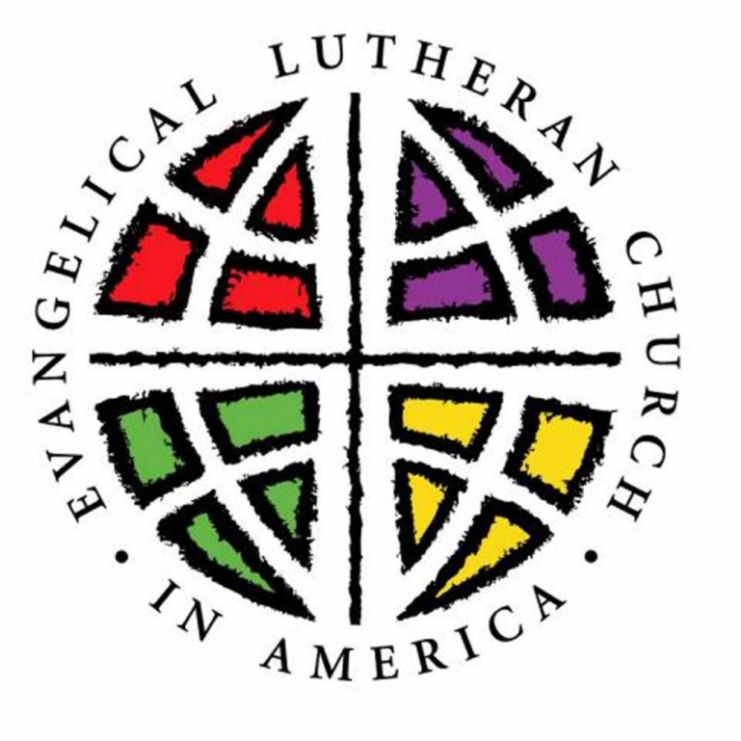

OS-TML News

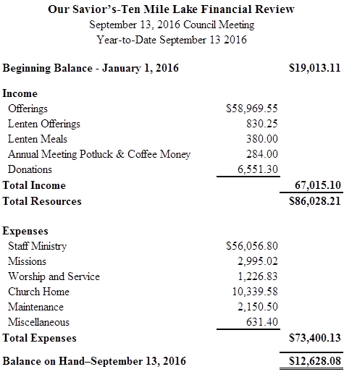

Gifts were received to the cemetery sign fund and memorial fund given in memory of Rodney Moebius, Val and Olive Demmer and Bill Demmer.  Thank you for these memorials. Blessed be their memories.

**Church Funnies**

A four year old was overhead praying: “And forgive us our trash baskets, as we forgive those who put trash in our baskets…”

A Sunday school teacher asked her children why it was necessary to be quiet in church. A bright little girl replied, “Because people are sleeping!”

A Sunday school teacher asked her class, “What was Jesus’ mother’s name?” They replied, “Mary.” Then she asked what his father’s name was. A little kid said, “Verge.” When asked how he came to that answer, he replied, “they always say Jesus was born to Verge ‘n Mary!”



OCTOBER:

1 Luke Zelie

2 Loren Frigaard

4 Brady Saurer

5 Charles Hansel

9 Jennifer Anderson

9 Amber Frigaard

9 Stacy Hansel

10 Dean Ness

10 Betty Skinnemoen

10 Holly Matson

11 Harlan Lien

14 Mitchell Sterns

15 Nancy Larson

15 Brenna Saurer

17 Verna Rude

21 Kathy Mounts

25 Logan Frigaard

25 Jane Junkert

25 Anna Thormodson

27 Cindy Bigelow

31 John Lill

31 Karen Nelson

31 Megan Sterns

**Advanced Care Planning Events**

LB Homes, Lakeland Hospice, and Lake Region HealthCare are sponsoring a screening of a PBS Frontline Special featuring Dr. Atul Gawande, author of the book ***Being Mortal***. This viewing will be followed by a panel with a chance for further discussion and questions. The screening will take place **Oct. 10** at the Light and Life Auditorium at Broen Home from **9-11am** and also from **7-9pm**. Pastor Matt will offer rides and carpools to the morning screening. If you are interested in arranging carpools for the evening screening, please let him know.

**Olson Funeral Home** in Fergus Falls is offering an informative and free session featuring elder law attorney Lisa Pluto. The session will feature information and questions and answers about estate and funeral planning. It will take place at Olson Funeral Home on **Oct. 11 at 2:00 pm**.

**Our Savior’s Lutheran Church**

US Postage Non-Profit Org

**PO Box 158** PAID

Dalton, MN 56324 Permit No. 5

**RETURN ADDRESS REQUESTED**

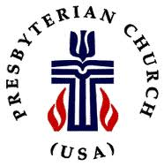 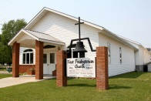

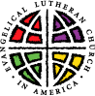 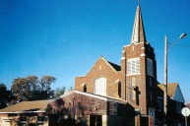

**___________________________________________________________**

**SHARED MINISTRY STAFF**

Pastor Matthew Zelie

Office Administrator: Jessica Zelie

OS-TML Office & Pastor’s Study: 589-8454 - 105 S. Central Ave.., PO Box 158, Dalton, MN 56324

First Presbyterian Church: 747-2744 - 202 Nelson St., PO Box 14, Ashby, MN 56309

Office Email – [ostml@prtel.com](mailto:ostml@prtel.com)

WORSHIP SCHEDULE

SUNDAY MORNING WORSHIP ~ TIME CHANGES

**9:00 am – Our Savior’s-Ten Mile Lake Worship**

Holy Communion the 1st and 4th Sunday

Coffee Fellowship – 3rd Sunday

**10:30 am – First Presbyterian Worship**

Holy Communion the 1st Sunday

**Make Worship A Part of Your Life**

**October 2016**

|  |  |  |  |  |  |  |
| --- | --- | --- | --- | --- | --- | --- |
| **Sunday** | **Monday** | **Tuesday** | **Wednesday** | **Thursday** | **Friday** | **Saturday** |
|  |  |  |  |  |  | 1 |
| 2  *(19th Sunday after Pentecost – Green)*  9:00am OS-TML H.C. Worship  10:30am First Presb H.C., Worship | 3 | 4  (No Parish Nurse)  12 pm Brown Bag  6pm Session Meeting | 5  9am Quilting (OSTML)  7pm Confirmation (Ashby) | 6 | 7 | 8 |
| 9  *(20th Sunday after Pentecost-Green)*  9:00am OS-TML Worship  10:30am First Presb, Worship | 10  9 am, 7pm “Being Mortal” Screening | 11  Parish Nurse 10am-12pm  12 pm Brown Bag  7pm Council Meeting | 12  9am Quilting (OSTML)  7pm Confirmation (Dalton) | 13 | 14 | 15 |
| 16  *(21stSunday after Pentecost-Green)*  9am OS-TMLWorship  10:30am First Presb, Worship | 17  7pm Shared Ministry Meeting | 18  Parish Nurse 10am-12pm  12 pm Brown Bag  2:30 Broen Home Communion  Newsletter deadline! | 19  (no quilting)  2pm WELCA  (no confirmation) | 20  (Pastor Matt on vacation 10/20-10/26) | 21 | 22 |
| 23  *(22nd Sunday after Pentecost-Green)*  9:00am OS-TML H.C. Worship  10:30am First Presb. Worship | 24 | 25  Parish Nurse 10am-12pm  (No Brown Bag) | 26  9am Quilting (OSTML)  (no confirmation)  First Presbyterian Fall Supper | 27 | 28 | 29 |
| 30  *(Reformation Sunday-Red)*  9:00am OS-TML H.C. Worship  (Blood Pressure Screenings)  10:30am First Presb. Worship | 31  Sunday School Trunk or Treat! |  |  |  | **THIS MONTH:**  **Oct. 18**- Feast Day of St. Luke the Evangelist  **Oct. 28**- Feast Day of St. Simon and St. Jude, Apostles  **Oct. 31**- Reformation Day |  |